

COURSE: | ARTIFICIAL INTELLIGENCE (LAB)
LAB: | # 9
NAME: | MUZAMMIL BIN SOHAIL
ROLL NO.: | 22F - 3110
DEGREE: | BS - AI
SECTION: | 4A1

Question 1:
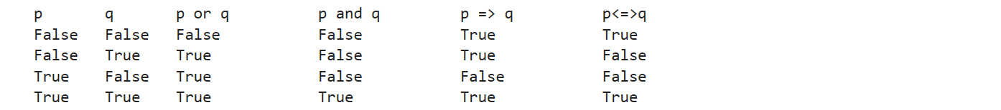
from utils import *
from logic import *

p = Symbol('p')
print(p)
q = Symbol('q')

print(f"{p}\t{q}\t{p} or {q}\t\t{p} and {q}\t\t{p} => {q}\t\t{p}<=>{q}")
for i in (False, True):
for j in (False, True):
print(f"{i}\t{j}\t{i|j}\t\t{i&j}\t\t{(not i)|j}\t\t{not(i^j)}")
Question 2:
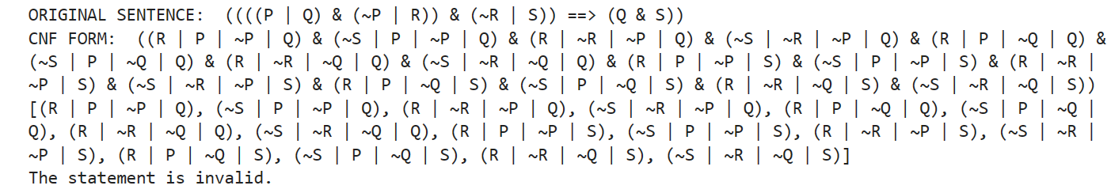
# Define the propositional symbols
P = Symbol('P')
Q = Symbol('Q')
R = Symbol('R')
S = Symbol('S')

sentence = (P | Q) & (~P | R) & (~R | S) | '==>' | (Q & S)
print("ORIGINAL SENTENCE: ", sentence)

print("CNF FORM: ",to_cnf(sentence))
print(final)

# Create the knowledge base (KB) from the statements in CNF
kb = PropKB()
kb.tell(P | Q)
kb.tell(~P | R)
kb.tell(~R | S)
kb.tell(~Q | ~S)

# Use resolution theorem prover to check if the KB entails the query
r1 = pl_resolve(~R | S, ~Q | ~S)
#print(r1)
r2 = pl_resolve(r1[0], P | Q)
#print(r2)
r3 = pl_resolve(r2[0], ~P | R)
#print(r3)

# Check if the empty clause is derived, indicating the statement is valid
if(len(r3)!= 0):
print("The statement is invalid.")
else:
print("The statement is valid.")
Question 3:

wumpus_kb = PropKB()

B21, P31, B41, S12, B32, W13, B23, S23,G23, P33, B43, S14, B34, P44 = expr("B21, P31, B41, S12, B32, W13, B23, S23,G23, P33, B43, S14, B34, P44")

for i in [B21, P31, B41, S12, B32, W13, B23, S23,G23, P33, B43, S14, B34, P44]:
wumpus_kb.tell(i)

wumpus_kb.clauses
wumpus_kb.ask_if_true(~P31)

